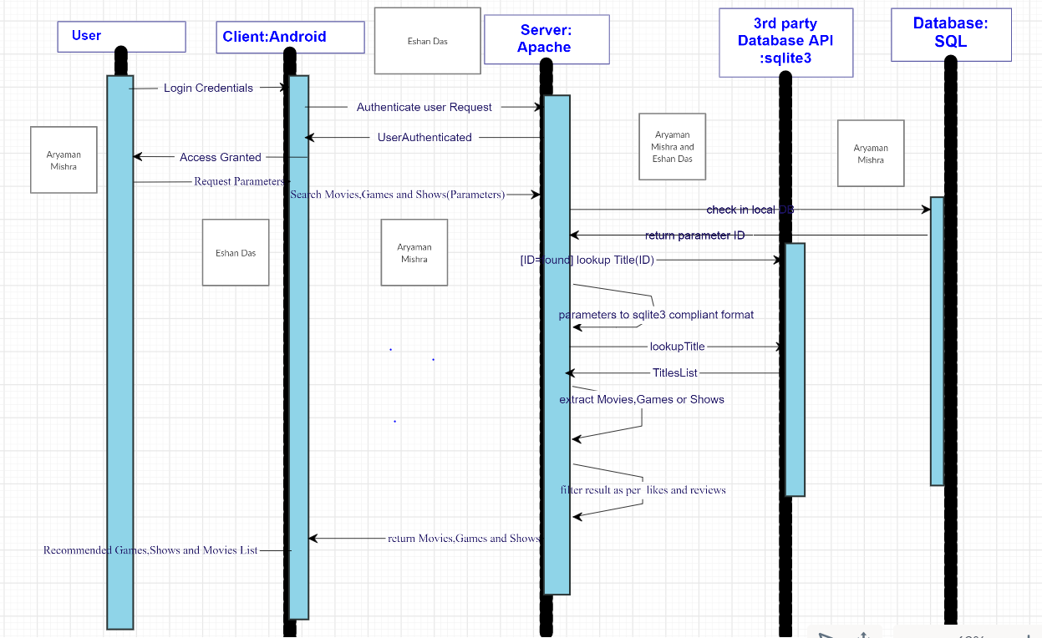

ARYAMAN MISHRA(19BCE1027),ESHAN DAS(19BCE1575)